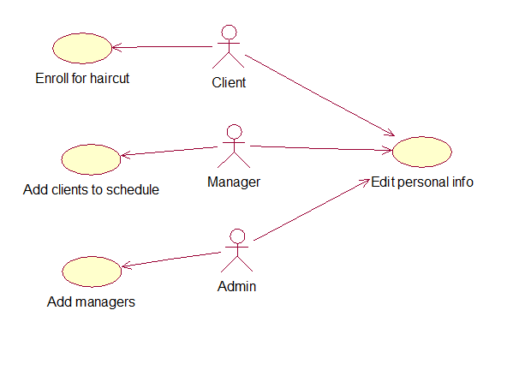

**Events flow for precedent «Enroll for haircut»**

Short description.

This variant clients to make an appointment with the hairdresser and choose specific data and time.

Main events flow

1. Client fills enrollment form, choose time, date.

2. System check whether data is correct.

3. System add user to certain manager schedule.

4. System create new meeting and saves to database.

Post conditions.

1. Data Base saves all changes.

2. Data Base update manager schedule.

**Events flow for precedent «Add clients to schedule»**

Short description.

This variant allows managers add clients to their working schedule.

Preconditions.

1. Manager should have site account.

Main events flow.

1. Manager inputs client information, time, date to schedule.

2. Manager saves or cancels inputed information.

3. System creates new meeting with inputed information

Post conditions.

1. Data Base saves all changes.

2. Data Base update manager schedule.

**Events flow for precedent «Add managers»**

Short description.

This variant allows admins add new managers.

Preconditions.

1. Being added manager shold be autorizied in system.

Main events flow.

1. Admin request users list.

2. Choose certain user.

3. Admin assigns new manager role to user.

Post conditions.

1. Data Base saves all changes.

**Events flow for precedent «Edit personal info»**

Short description.

This variant allows users edit their personal information, name, phone, password, etc.

Preconditions.

1. User should have site account.

Main events flow.

1. User requests self-data.

2. System output form with data.

3. User inputs/changes data.

4. User saves data or cancels (back to 1-point)

5. System updates database.

Post conditions.

1. Data Base saves all changes.